AP Chemistry 11 Communication Plan
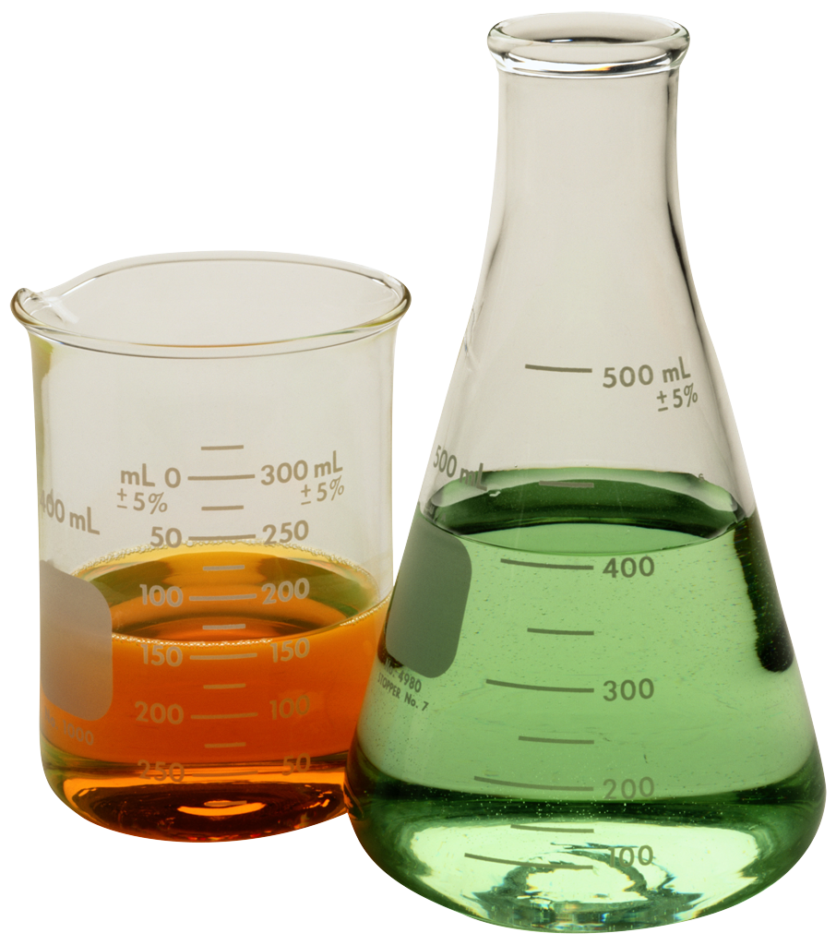
According to the AP Chemistry Course Description, this course is designed to follow a full year of chemistry at the university level. This means you will be learning the same material, both in amount and depth as a university student in their first year. If you are able to learn and retain the information we will discuss in this course, then you will have the opportunity to receive a university level credit. WARNING: This is not for slackers! You will need to work hard and keep up with both the difficult concepts and the workload of this course. Be prepared for a tough, but interesting time this semester.

Expectations:
Punctuality: Students should be to class on time. If a pupil is more than 2 minutes after the bell, then the door to my classroom will be shut and the pupil should KNOCK and WAIT for me to open the door. If you are late, then I will discuss the reasons with you AFTER class. When being late begins to interfere with your learning—i.e. you are late 3 times—then I will phone home to discuss the problem with your parents/guardians.

Attendance: Students should be in class, period. If a pupil misses a class, then a written note or phone call will be expected upon their return to class explaining the absence. If you miss a class, then it is your responsibility to see me to get any work you may have missed. Don’t miss class because your marks will suffer and you’ll miss out on the fun!! If you miss a test day and you have no excuse, then you will receive a zero for that test. If you do have a note, then you will write the test your first day back.

Responsibilities: 1) You are responsible for YOUR OWN ACTIONS. Nobody else can control what you do. (2) You are expected to be respectful of others in the class. This includes members of the class, the teacher, and guests to the class, but most importantly, have some respect for you! Racial, sexist, and homophobic remarks will be STOMPED OUT as they are NOT tolerated in room 208! Remember you are in a classroom, which is a place of work, and you should act accordingly.

Participation and Work-rate: Every member of the class is expected to participate in group activities and class discussions/debates. Pupils who work well will be rewarded with good marks in this class. I expect every person in this class to strive for excellence and to do the best they possibly can and I will push you to do so!

Textbooks: Each of you will be loaned a textbook for the semester. The textbooks are numbered so I can keep track of them. You are responsible to pass in the textbook on the day of the exam. Failure to pass in the textbook will result in an INCOMPLETE for this course. It is also recommended that you cover your textbook. Do not write in or highlight your textbook!

Classroom Rules:
Three simple rules: 1) Don’t talk while I’m talking—I really hate that! (This also includes if another member of the class is talking). (2) No food or drinks—except water—in the classroom. (3) CLEAN UP AFTER YOURSELF!!! (4) Cell phones are not to be used in the classroom. Students will be asked to place their cell phones in the “cell phone babysitting basket” at the beginning of class. If they choose not to, and subsequently get caught with their cell phone out, then an office referral will follow.

Extra Help:
This class is not easy. It is challenging and requires a lot of work outside of class. If you want to get a mark in the 80’s, then studying just the night before will not suffice. Therefore, as soon as you THINK you are having difficulty I expect you to do the following: 1) Set up a time for extra help—your peers are not qualified chemistry teachers, but I AM! (2) Set up a study schedule to be checked by me and parents if necessary. (3) Bring any questions to your extra help sessions. You must come to the extra help session whether you think you need to or not!

Assignment Completion: All assignments must be completed, or students will get an incomplete for their mark. Due dates will be set for assignments. If the assignments are not completed by the due date, then the student will be referred to the Assignment Completion Room.

Course Outline – AP Chemistry 11
- Chemistry basics – review
  - The science of chemistry
  - Measurement and units
  - Significant digits and their use in calculations
  - Dimensional analysis
  - Classification of matter
  - Atoms, molecules and ions
  - Types of compounds and the naming of compounds

- Stoichiometry
- Atomic mass, mole, and molar mass relationships
- Percent composition
- Calculation of empirical and molecular formulas
- Writing and balancing chemical equations
- Use of balance equations to perform stoichiometric calculations
- Limiting reactants
- Percent yield

- State of Matter
- Gas pressure
- Gas laws
- Stoichiometry involving gases
- Kinetic theory of gases
- Real gases versus ideal gases

- Types of Chemical Reactions and Solution Chemistry
- The chemical nature and structure of water
- Strong and weak electrolytes
- Aqueous solutions
- Types of chemical reactions

- Atomic Structure and Periodicity
- Electromagnetic radiation
- The Bohr and quantum mechanical models of the atom
- Electron configuration
- The periodic table and periodic trends

- Chemical Bonding
- Binding Forces
- Molecular Models
- Geometry of molecules and ions
- Nuclear chemistry

7. Organic Chemistry
- Hydrocarbons
- Functional groups

Contact Me:
E. Monahan
Phone: 644-5000
E-mail: emonahan@staff.ednet.ns.ca
Website: http://ssrsbstaff.ednet.ns.ca/emonahan

